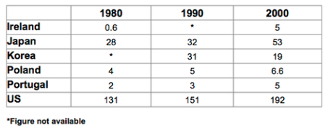

The chart compares the amounts of waste that were produced in six different countries in the year 1980, 1990 and 2000.

In each of these years, the US produced more waste than Ireland, Japan, Korea, Poland and Portugal combined. It is also noticeable that Korea was the only country that managed to reduce its waste output by the year 2000.

Between 1980 and 2000, waste production in the US rose from 131 to 192 million tons, and rising trends were also seen in Japan, Poland and Portugal. Japan’s waste output increased from 28 to 53 million tons, while Poland and Portugal saw waste totals increase from 4 to 6.6 and 2 to 5 million tons respectively.

The trends for Ireland and Korea were noticeably different from those described above. In Ireland, waste production increased more than eightfold, from only 0.6 million tons in 1980 to 5 million tons in 2000. Korea, by contrast, cut its waste output by 12 million tons between 1990 and 2000.

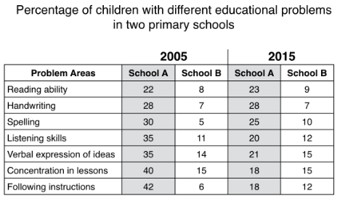

The table compares two primary schools in terms of the proportion of their pupils who experienced seven different educational problems in the year 2005 and 2015.

It is noticeable that school A had higher proportions of children with all seven educational difficulties in both years. However, while school A managed to reduce the incidence of most of the problems between 2005 and 2015, school B saw an overall rise in the percentage of children who were struggling.

In 2005, 42% of school A’s pupils found it difficult to follow instructions, whereas only 6% of pupils in school B experiences this problem. Similarly, between 30 to 40 percent of children attending school A had problems in the areas of spelling, listening, verbal expression and concentration in lessons, while the equivalent figures for school B stood at between 5 to 15 percent.

In 2015, the difference between the two schools was less pronounced. Notably, the proportion of children who struggled to follow instructions fell by 24% in school A, and this school also saw falls of 22%, 15%, 14% and 5% in the figures for children who had problems with concentration, listening and verbal expression and spelling. In school B, however, the proportion of children who struggled with spelling and following instructions doubled, to 10% and 12% respectively, and there was almost no change in the incidence of listening, verbal expression or concentration problems.